
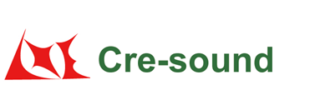
Product Code:
Test Self-Oscillaton Circuit

LPF2965-TA-12-3.0-R

Picture:`
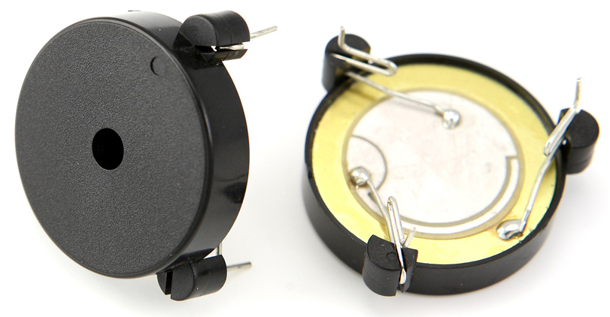

Specification:

Rated Voltage | (VDC) | 12
Operating Voltage | (VDC) | 3～20
*Rated Current | (mA) | ≤12
*Sound Output at 10cm | (dB) | ≥90
*Resonance Frequency | (KHz) | 3.0±0.5
Operating Temperature | (℃) | -40～+85
Storage Temperature | (℃) | -40～+90
Weight | (g) | 3.7
Housing Material |  | ABS
RoHS |  | Yes
*Value applying at rated voltage.
Test basic state: Temp(20±2℃) , Humidity(40~70%RH) , Air pressure(860~1060hPa).
market@wj-lianhua.com Tel:86-519-86321175 86322167 Fax:86-519-86702455 www.cre-soundbuzzer.com www.wj-lianhua.com

Dimensions (Unit: mm)
Tolerance: ±0.5mm Except Specified

